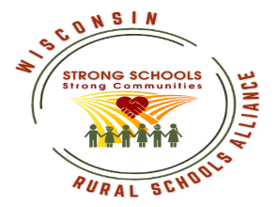
Wisconsin Rural Schools Alliance
Scholarship Application – Graduating Senior
2021-22

Submit to Mrs. Troxel by January 28, 2022
(Deadline for schools to submit to WiRSA is February 18, 2022)

Applicant Name Click here to enter text.

Home Address Click here to enter text.

Home Phone Number Click here to enter text.

Parent(s)/Legal Guardian(s) Name(s) Click here to enter text.

School District Click here to enter text. CESA Click here to enter text.

Grade Point Average Click here to enter text.Class Rank/Other System Click here to enter text.

Number in Class Click here to enter text.

List involvement in community and civic service. Click here to enter text.

List involvement in extra-curricular activities. Click here to enter text.

List any special honors, awards, or recognition you have received. Click here to enter text.

Attach to this application (not to exceed a total of two typewritten pages) a description of:
- The benefits of attending a rural school.
- Your college and career goals; and,
- The value of growing up in a rural community and what are the personal values you have gained from this experience.

_________________________________________ ___________________
Applicant Signature Date

_________________________________________ ___________________
School Counselor Signature Date

